OS - Experiment 1

Name: Kartik Jolapara Sapid: 60004200107

Div./Batch: B/B1 Branch: Computer Engineering

# AIM:

Explore the internal commands of Linux and Write shell scripts to do the following.

## 1. Display top 10 processes in descending order

codingmickey@DESKTOP-DC7H32B:~ $ echo "Top 10 processes in descending order" && ps axl | head -n 10

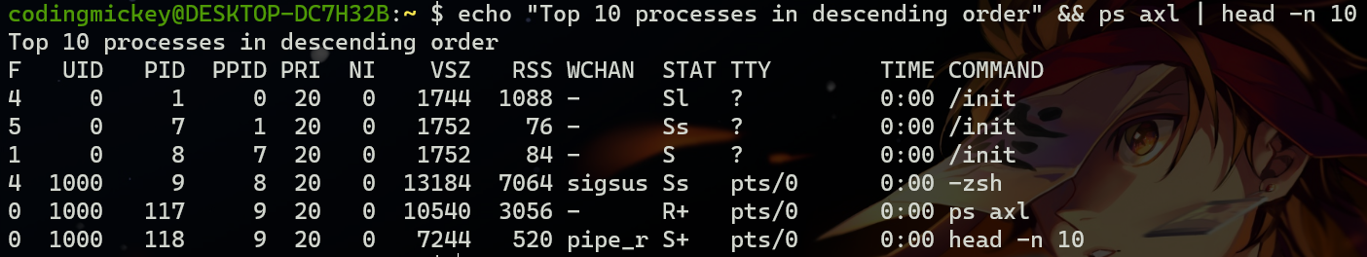

## 2. Display processes with highest memory usage.

codingmickey@DESKTOP-DC7H32B:~ $ ps -eo pid,ppid,cmd,%mem,%cpu --sort=%mem |head

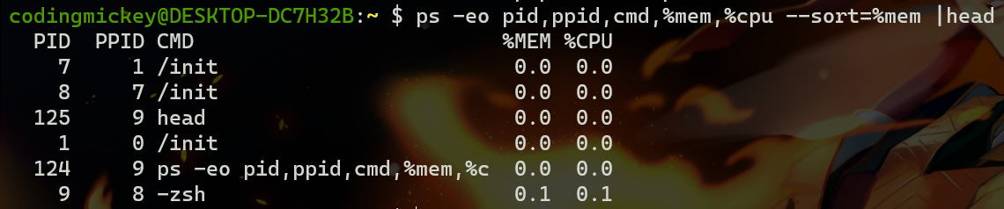

## 3. Display current logged in user and no. of users.

codingmickey@DESKTOP-DC7H32B:~ $ who -u  
codingmickey@DESKTOP-DC7H32B:~ $ who -u | wc -l

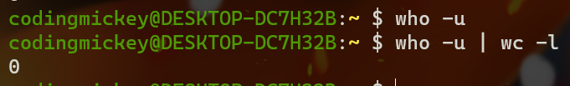

## 4. Display current shell, home directory, operating system type, current working directory.

codingmickey@DESKTOP-DC7H32B:~ $ whoami  
codingmickey@DESKTOP-DC7H32B:~ $ uname  
codingmickey@DESKTOP-DC7H32B:~ $ pwd  
codingmickey@DESKTOP-DC7H32B:~ $ uname

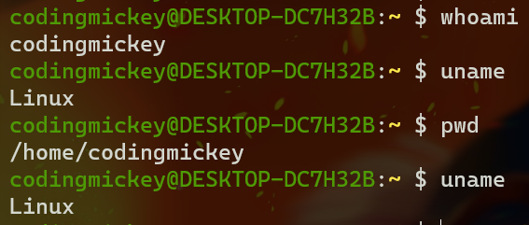

## 5. Display OS version, release number.

codingmickey@DESKTOP-DC7H32B:~ $ uname -a  
codingmickey@DESKTOP-DC7H32B:~ $ uname -r



## 6. Illustrate the use of sort, grep, awk, etc.

codingmickey@DESKTOP-DC7H32B:~ $ cat > boring  
codingmickey@DESKTOP-DC7H32B:~ $ ls  
codingmickey@DESKTOP-DC7H32B:~ $ cat boring  
codingmickey@DESKTOP-DC7H32B:~ $ sort boring  
codingmickey@DESKTOP-DC7H32B:~ $ sort boring > abc  
codingmickey@DESKTOP-DC7H32B:~ $ ls  
codingmickey@DESKTOP-DC7H32B:~ $ cat abc  
codingmickey@DESKTOP-DC7H32B:~ $ awk '{print $1 "\t"$2}' boring

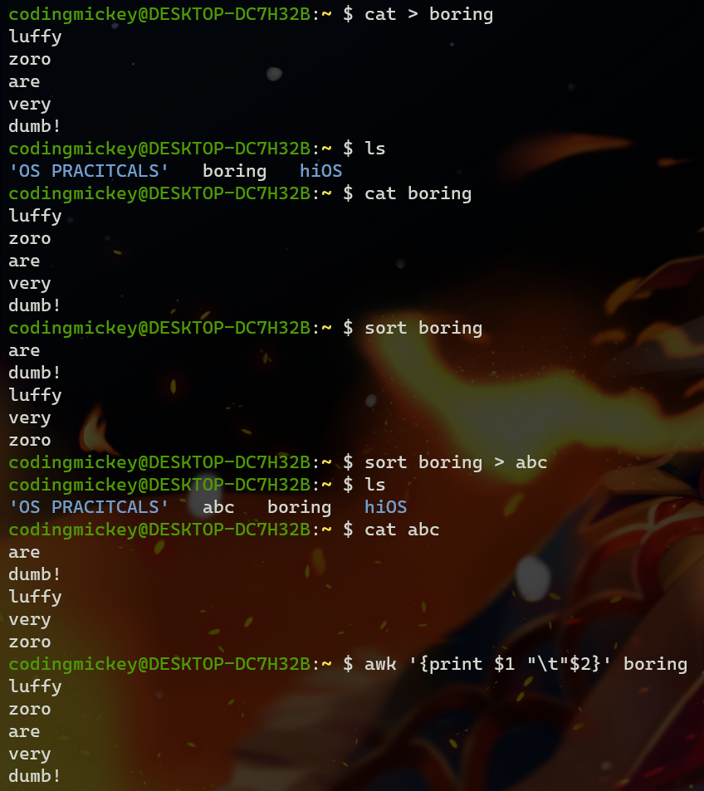

# Conclusion:

The Linux based operating systems have a wide variety of commands

or system calls that can be invoked through the command line or shell,

like bash, to perform system and functions. Linux provides a more

open approach to its system calls compared to other operating

systems based on the UNIX philosophy. Linux based systems are

developed to be able to be used only from the command line using the

the terminals without the need of a GUI. Hence the commands

present cater to every aspect of the system from daily use to system

diagnostics.